**Objective:**

The objective of the lab experiment was to provide an introduction to Amazon Elastic Compute Cloud (EC2) and teach the user how to launch and connect to an EC2 instance in AWS. EC2 is Amazon's cloud computing platform that allows users to quickly and easily spin up virtual machines on demand. During the lab, I learned the basics of EC2 and how to select the right instance type, launch an instance, and connect to it using SSH.

The first step was to select the EC2 instance type that was most suitable for the task. I had to consider the instance type, size, pricing, and other features that provided the best performance for the workload. After selecting the appropriate instance type, I was ready to launch the instance.

The next step was to launch the instance. I had to specify the instance type, image, security group, and other parameters and then launch the instance. Once the instance was launched, I had to connect to it using SSH. I had to generate a key pair and then specify the path to the key file while connecting to the instance.

Through this lab, I gained a comprehensive introduction to EC2 and hands-on experience of launching and connecting to an EC2 instance in AWS. I learned how to select the right instance type, launch an instance, and connect to it using SSH.

**Procedure:**

The lab focused on the creation of a new key pair and security group and the launching an EC2 instance with the specified key pair and security group. The key pair was created in the AWS Console and the security group was also created in the AWS Console. The EC2 instance was then launched with the specified key pair and security group.

The lab then covered how to configure the instance details, such as instance type, network settings, and storage. The instance type could be set to a specific type, such as t2.micro, or left as the default. Network settings were configured to allow inbound and outbound traffic from the specified IP address. Lastly, the storage was configured to provide the desired amount of storage to the instance.

Once the instance was launched and configured, the lab concluded with a successful launch of the EC2 instance. The key pair and security group were created and configured correctly, and the instance was launched with the correct settings. This lab was a great introduction to the basics of Amazon EC2 and how to launch and configure EC2 instances.

The next step in the lab was to demonstrate how to connect to an EC2 instance using SSH and run some basic Linux commands. To make this process easier, screenshots were provided to guide the user through each step. To connect to the EC2 instance, the user first had to generate a key pair in the AWS console. After that was done, the user had to open their terminal, and enter the command ssh -i <path to the key pair file> ec2-user@<public DNS of the instance>. This command established an SSH connection between the user's computer and the EC2 instance.

Once the connection was established, the user was able to run basic Linux commands on the instance. For example, the user could use the command ls to list the contents of a directory or use the command cd to change to a different directory. These commands allowed the user to navigate and manipulate files on the instance.

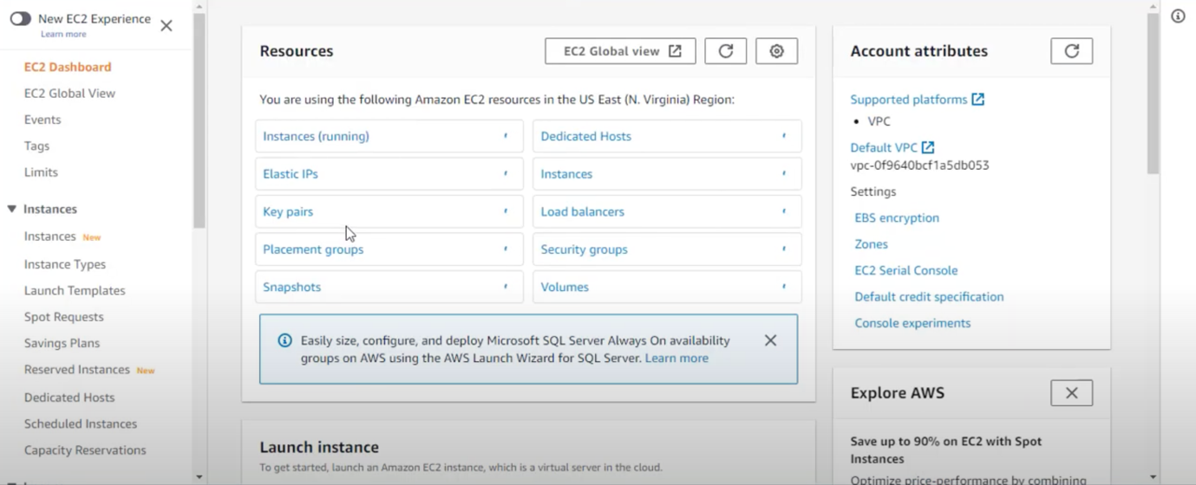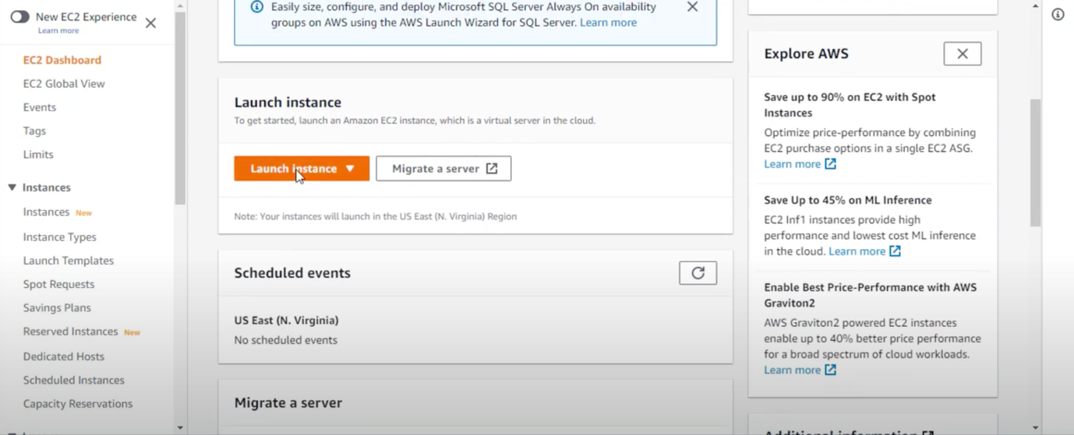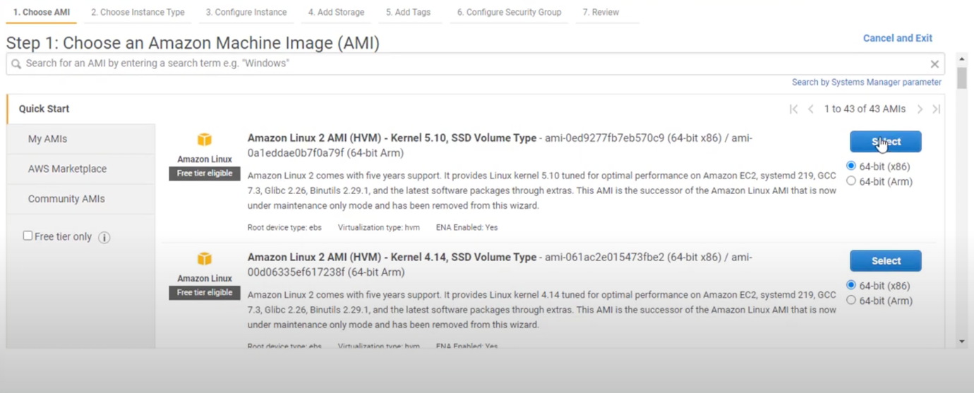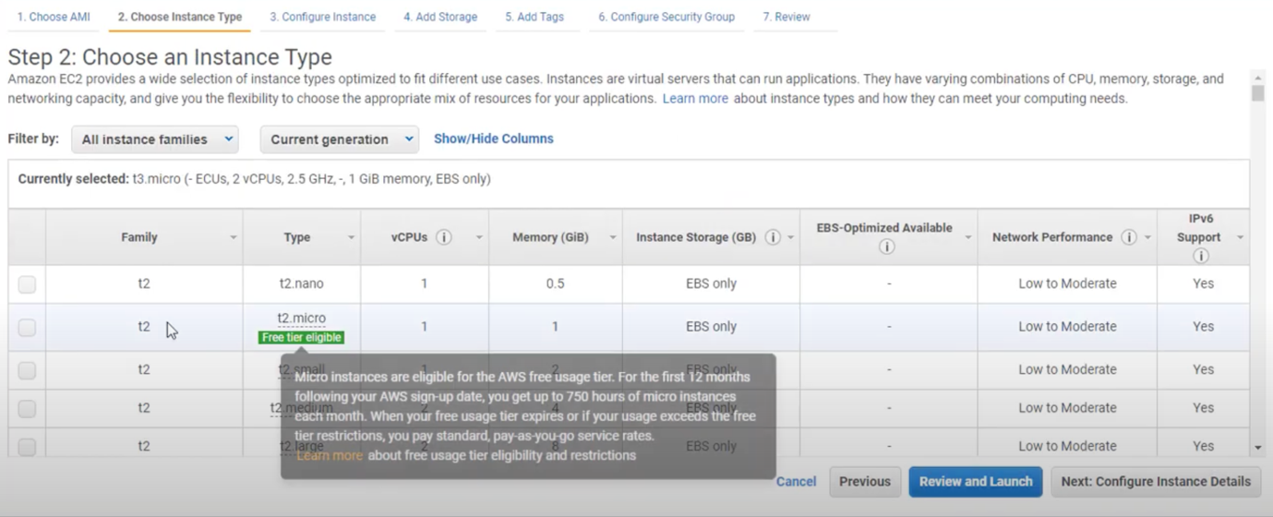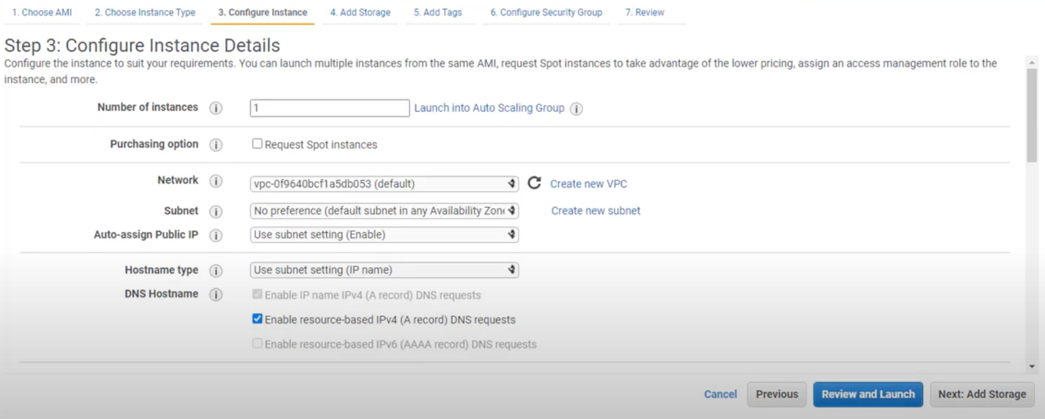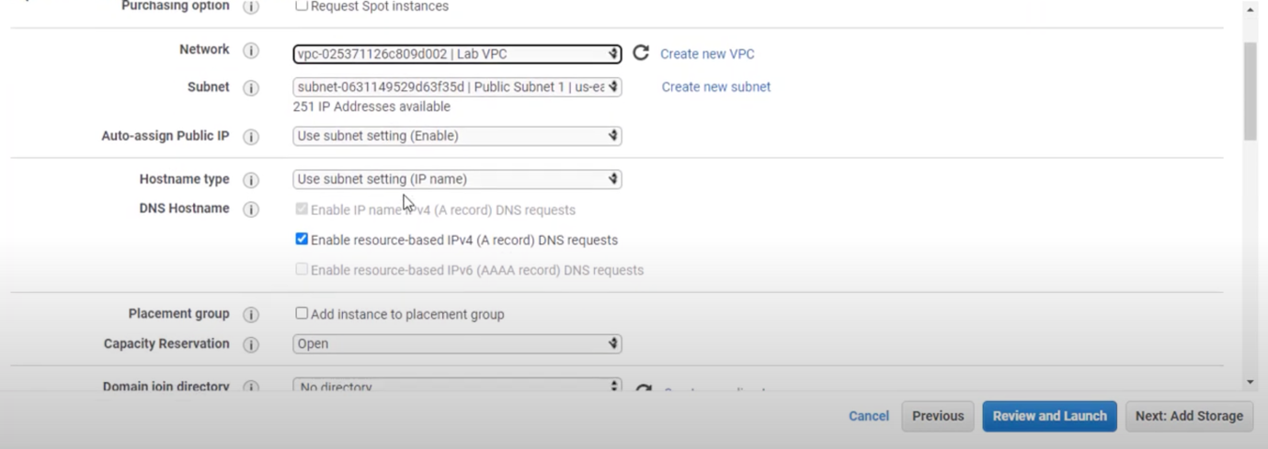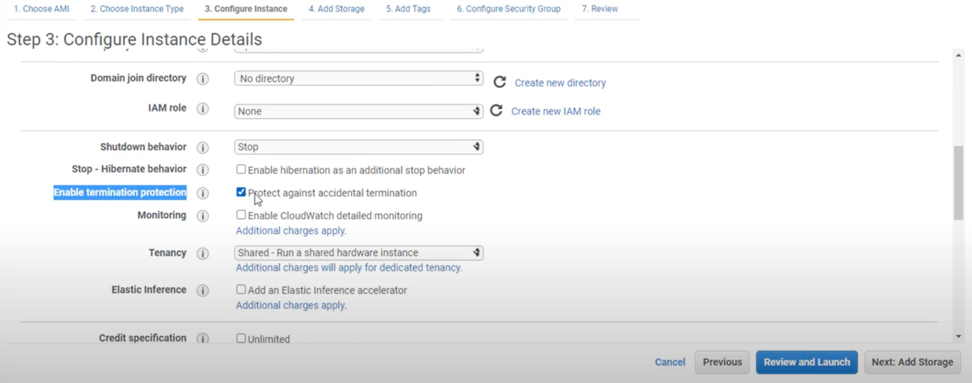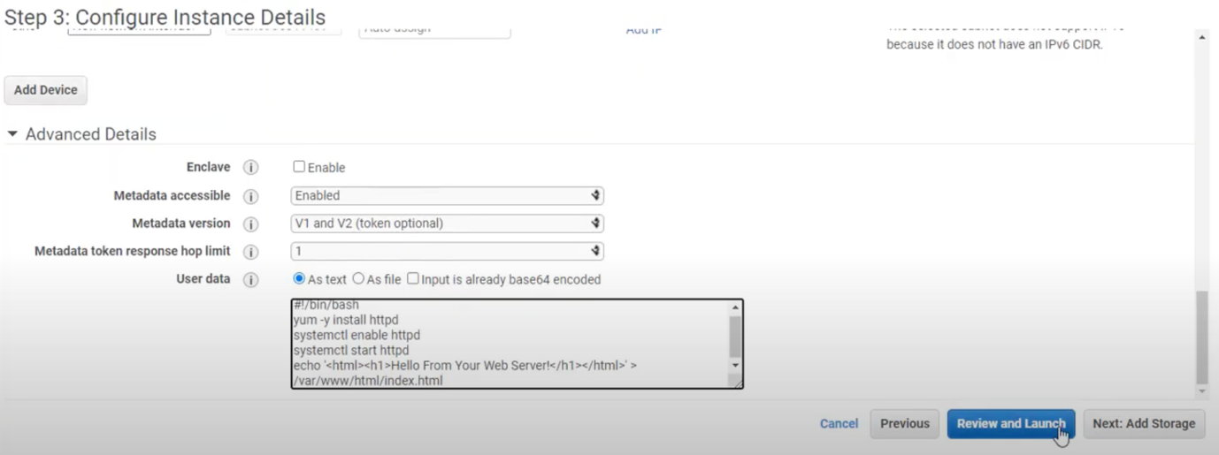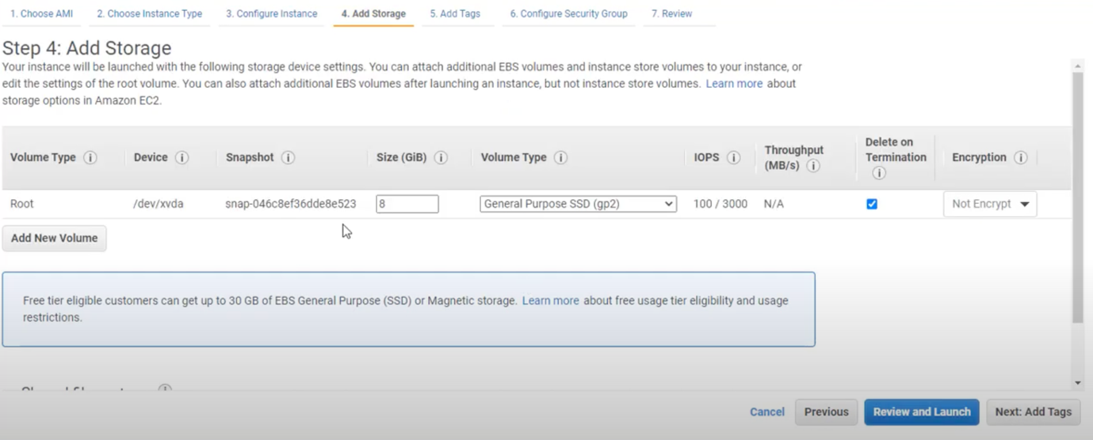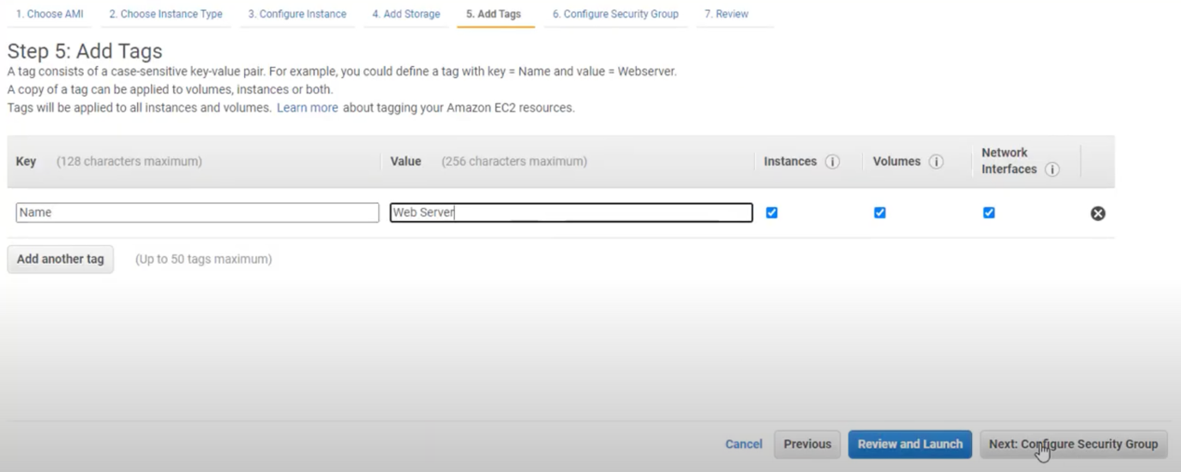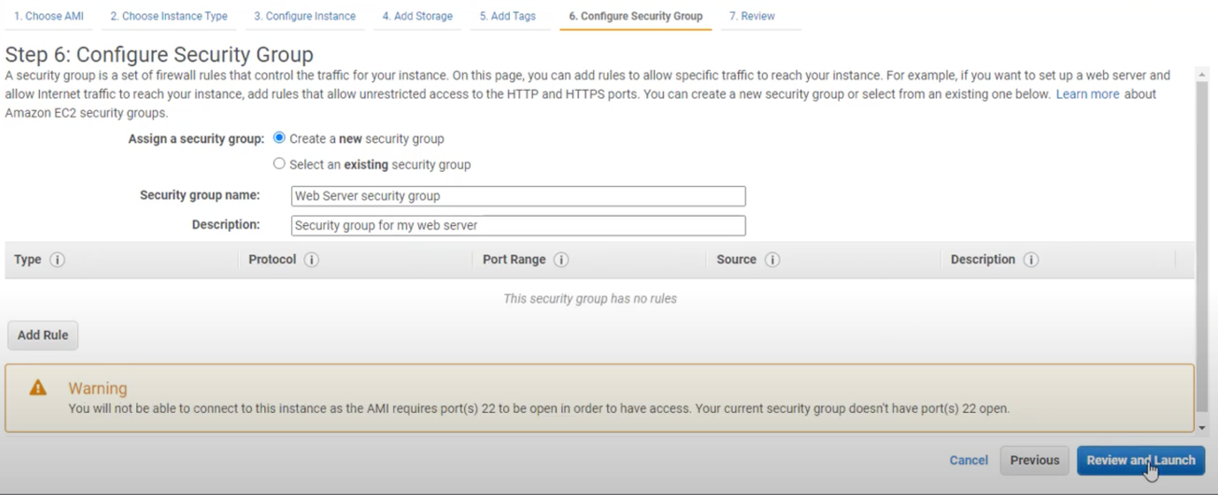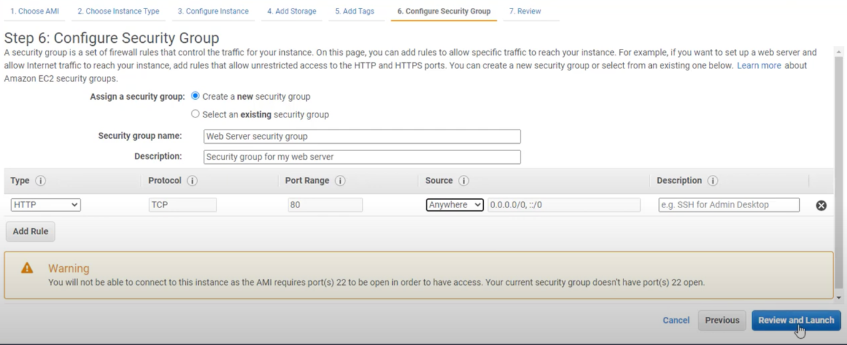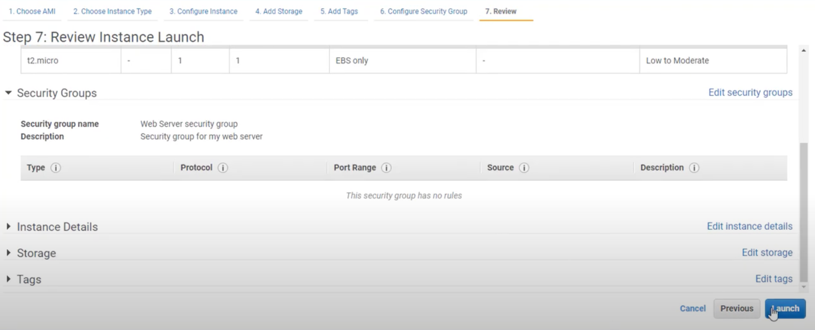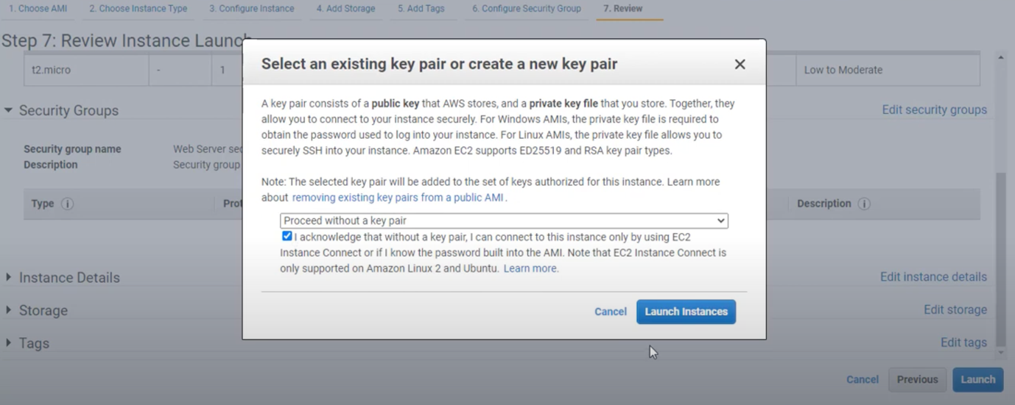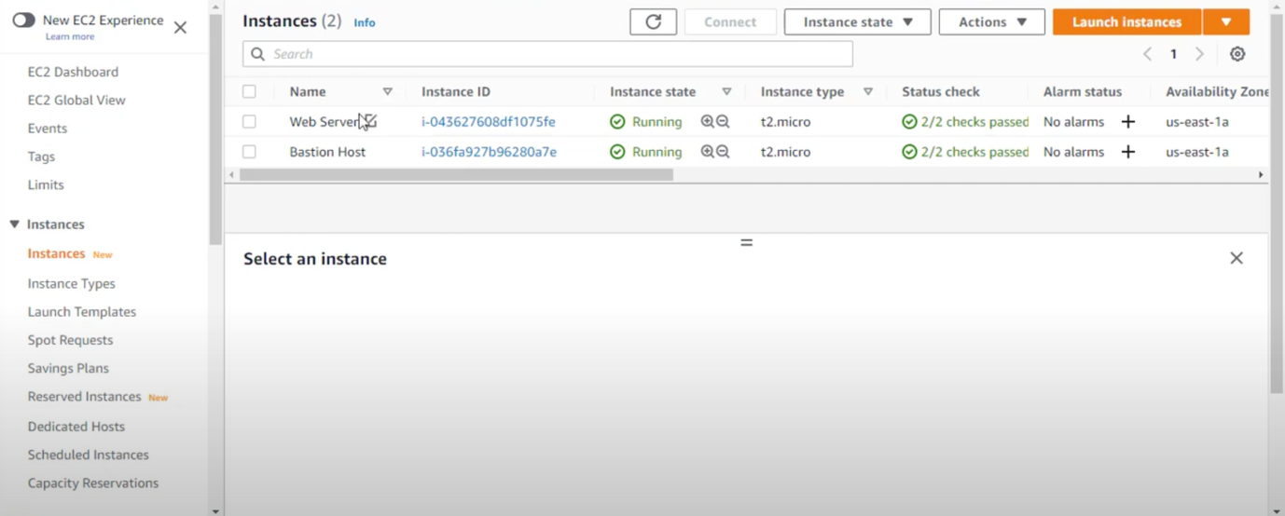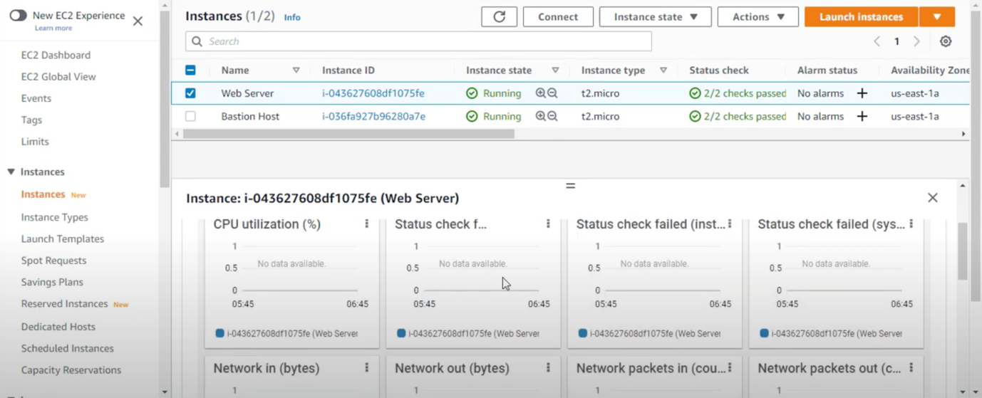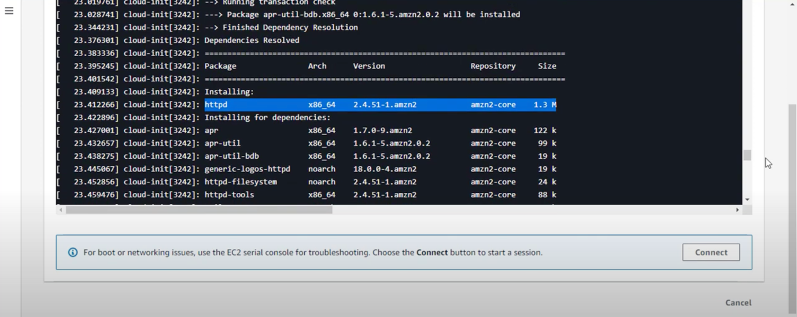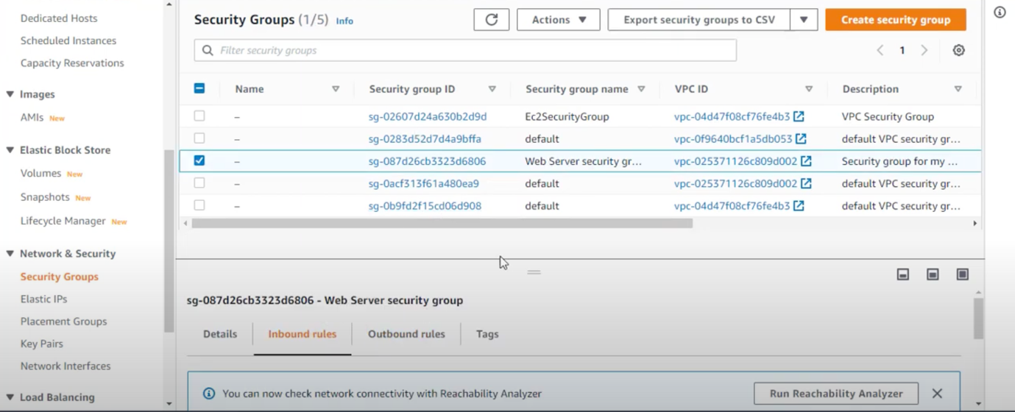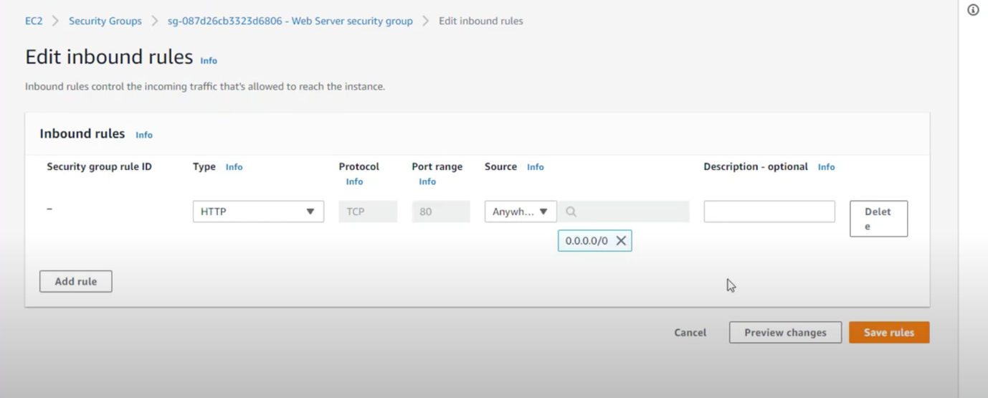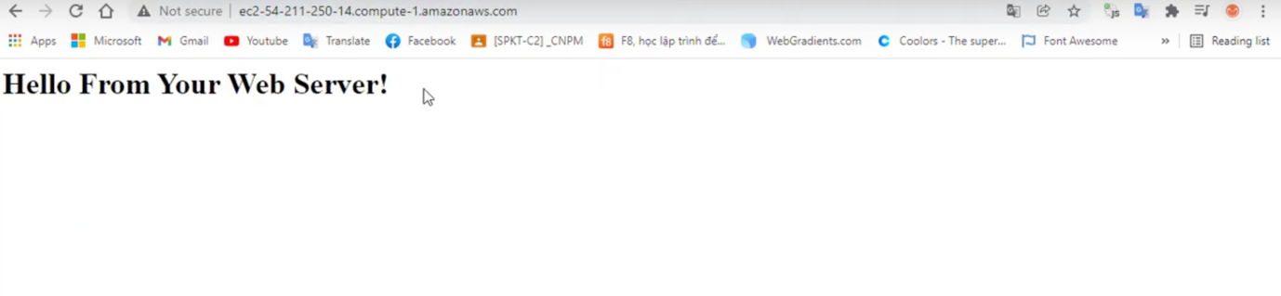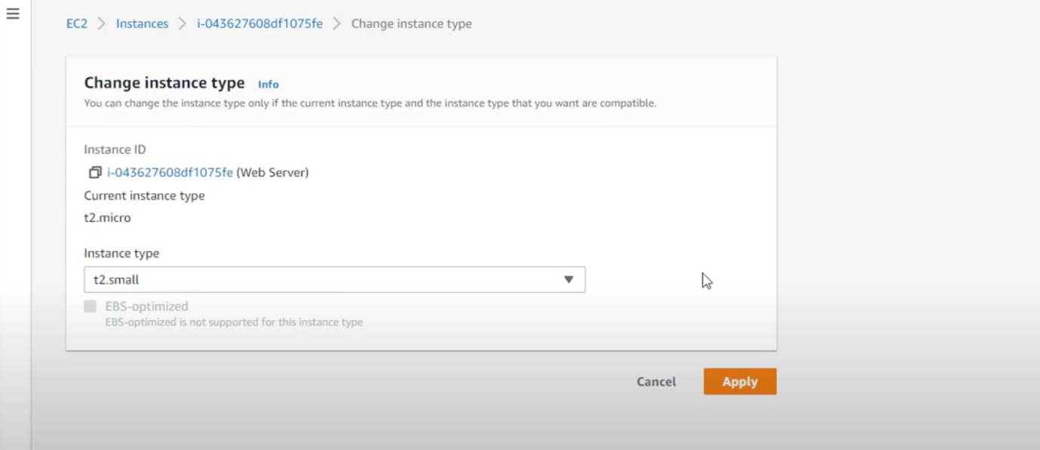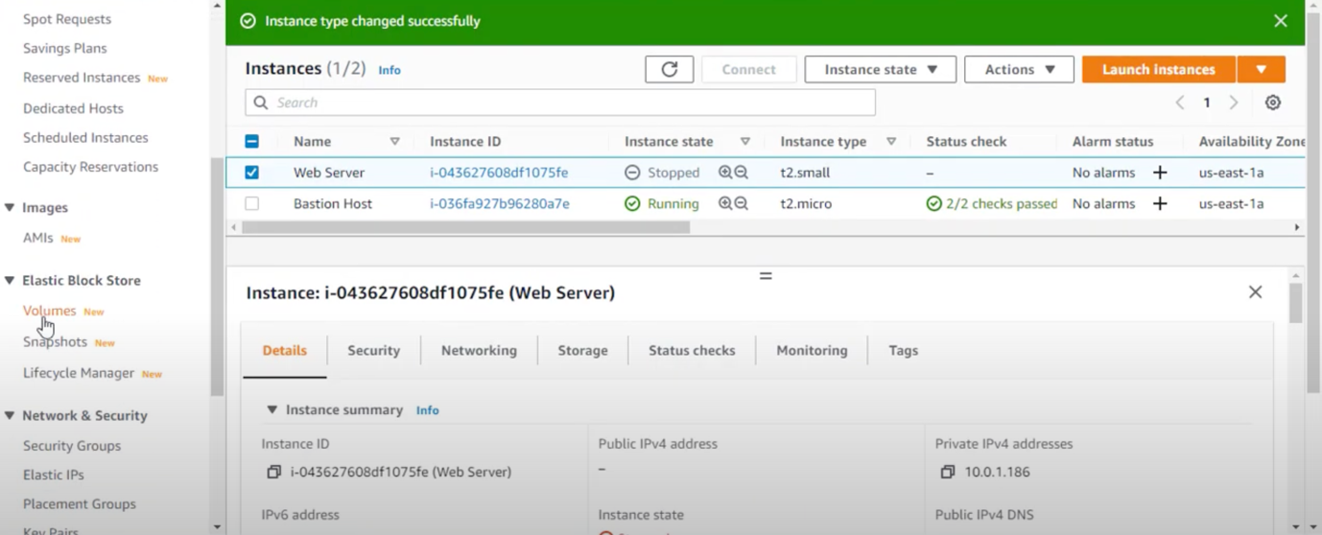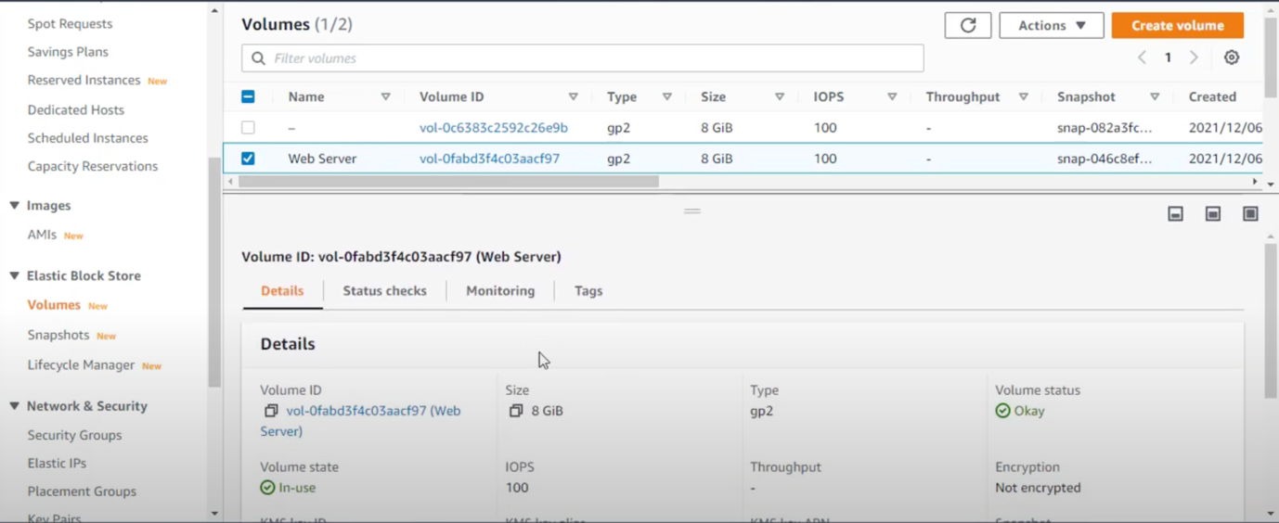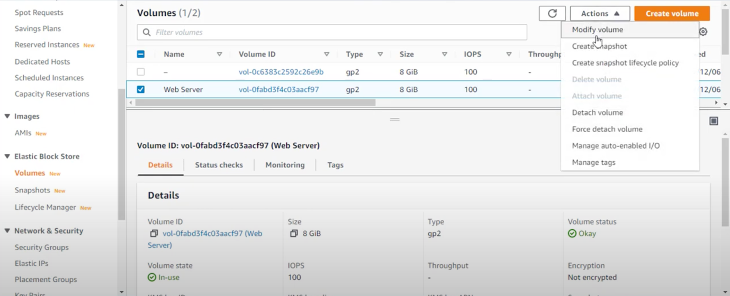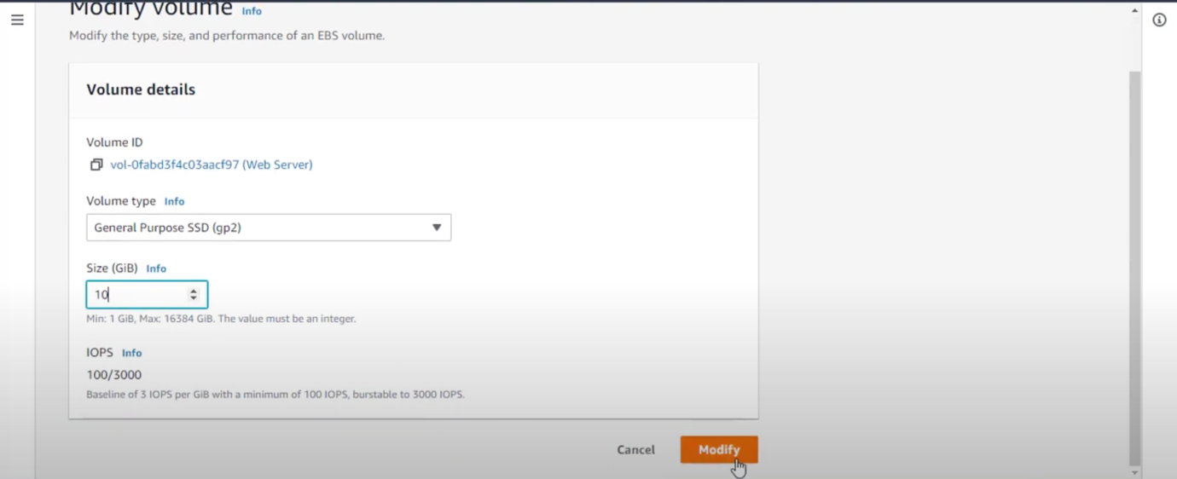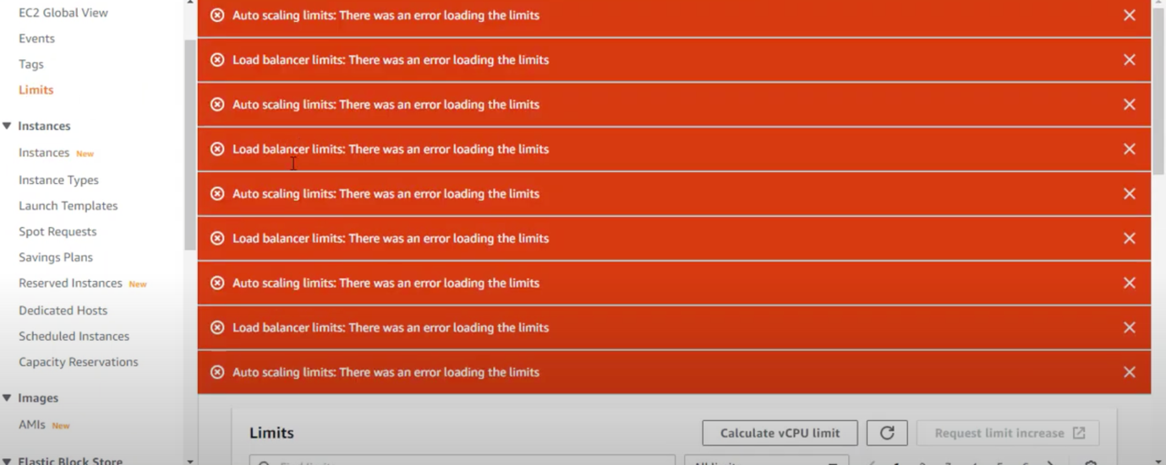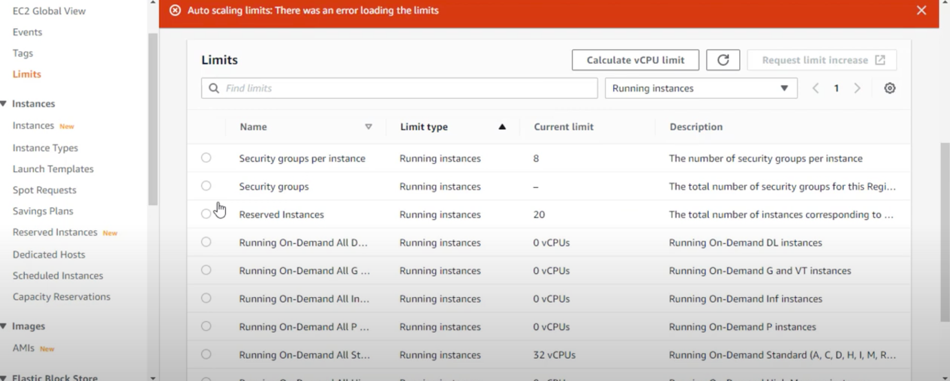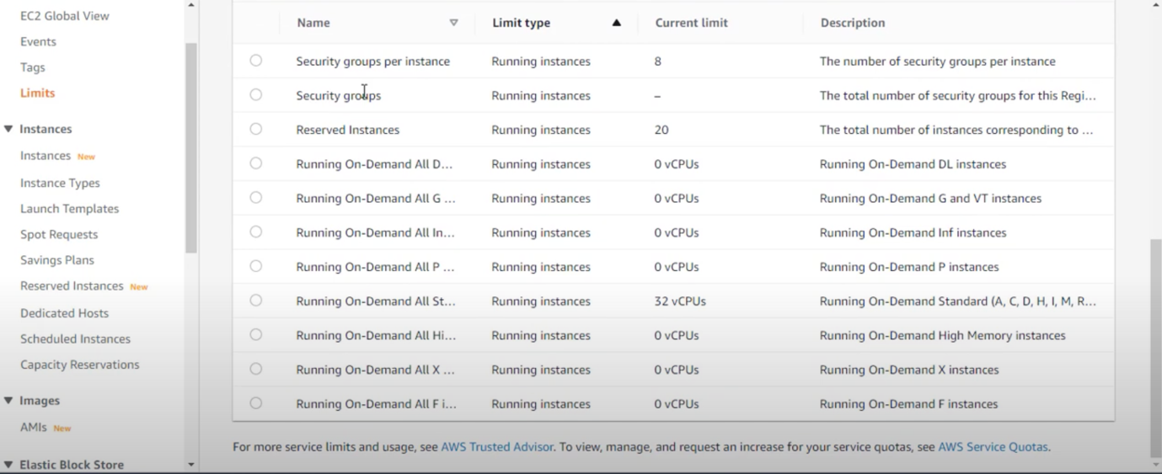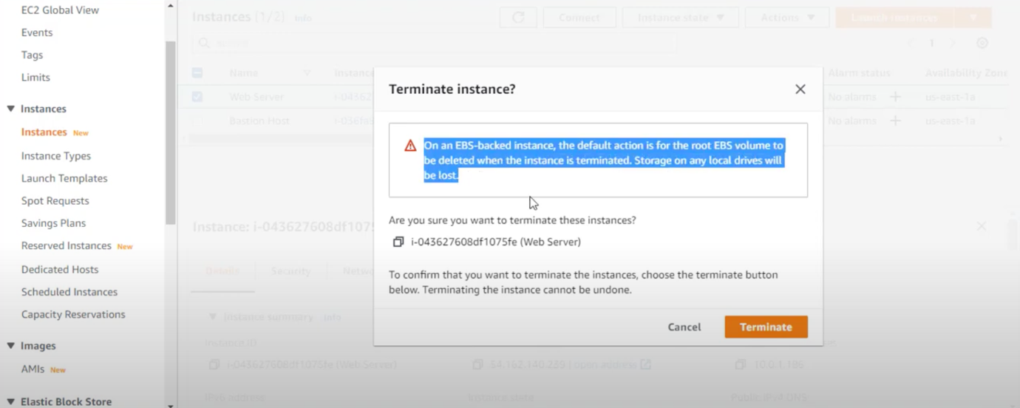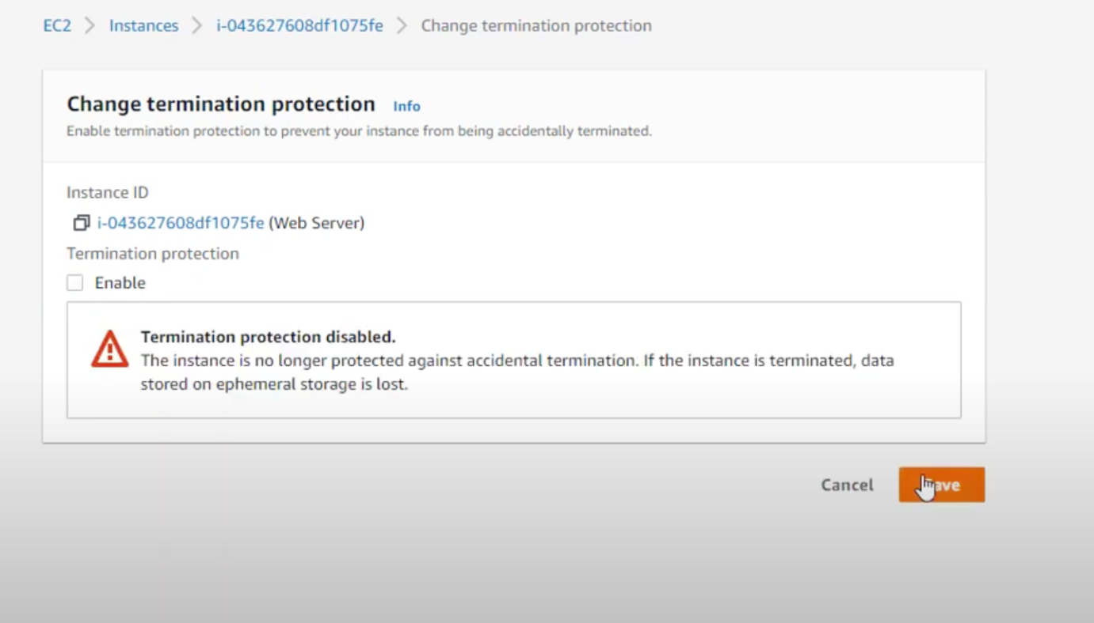

**Developing Knowledge:**

Learning how to launch and connect to an EC2 instance in Amazon Web Services (AWS) was the most beneficial part of this activity. This was particularly useful in helping me to understand how to create, manage, and access EC2 instances securely. I gained a better appreciation of EC2's features and capabilities, and it gave me the confidence to create, configure, and manage EC2 instances securely. Additionally, I learned more about the use of SSH keys, security groups, and other security features that are necessary for a secure connection. Overall, this part of the activity was invaluable in terms of helping me to acquire the knowledge necessary for working with EC2 instances.

**Difficulties and Incompleteness:**

I encountered some challenges while working through this lab. Connecting to the instance using SSH and troubleshooting connectivity issues were particularly difficult for me. However, the instructions provided were very helpful and I was able to complete the lab in its entirety. I was satisfied with the outcome, but I would have appreciated more in-depth explanations on some steps. By exploring these issues more thoroughly, I would have been able to gain a better understanding of the concepts at hand.